Implement A* algorithm for 8 Puzzle Problem

Case 1:f(n)=g(n)+h(n)
Where h(n) is the number of misplaced tiles
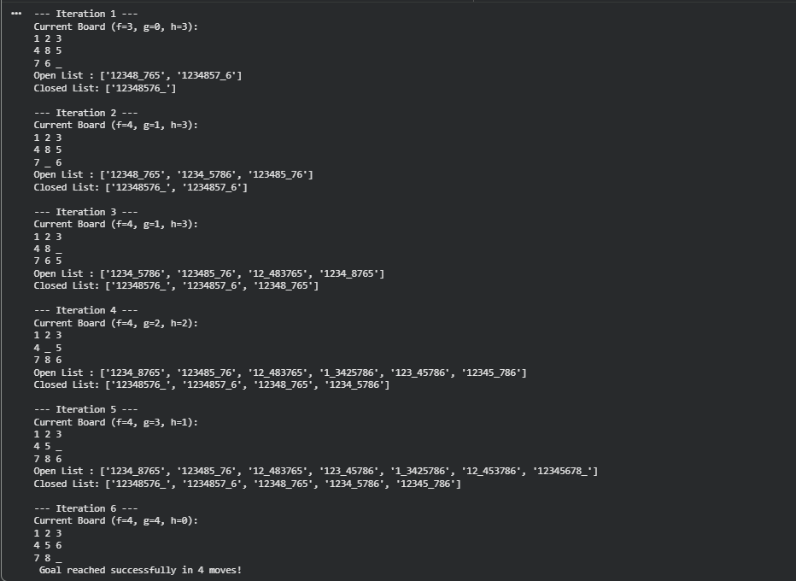

Case 2:
F(n)=g(n)+h(n) where h(n) is the Manhatten distance of the tiles
